## Exercise 1: Sum Adjacent Equal Numbers

Write a program to sum all adjacent equal numbers in a list of decimal numbers, starting from left to right.

Examples:

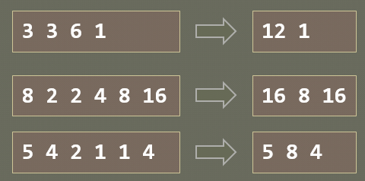

## Exercise 2: Gauss' Trick

Write a program that sum all numbers in a list in the following order:

first + last, first + 1 + last - 1, first + 2 + last - 2, … first + n, last – n

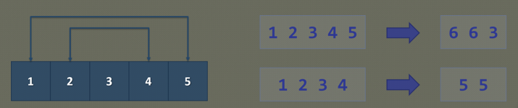

## Exercise 3

* Define a class Student, which holds the following information: **ID, Name** and **Age**.
* Create a list of students
* Sort the list by Name and print it.

## Exercise 4: Cars

**NOTE**: You need a public StartUp class with the namespace Cars.

Build a **hierarchy** of **interfaces** and **classes**:

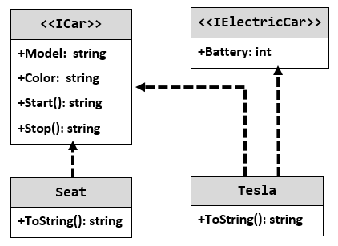

Your hierarchy must be used with this code:

|  |
| --- |
| StartUp.cs |
| ICar seat = new Seat("Leon", "Grey");  ICar tesla = new Tesla("Model 3", "Red", 2);  Console.WriteLine(seat.ToString());  Console.WriteLine(tesla.ToString()); |

### Examples

|  |
| --- |
| **Output** |
| Grey Seat Leon  Engine start  Breaaak!  Red Tesla Model 3 with 2 Batteries Engine start  Breaaak! |